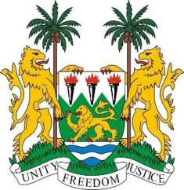
SIERRA LEONE

27th Session of the UPR

BRAZIL

5 May 2017

Mr President,

Sierra Leone welcomes the high-level delegation from Brazil to this review cycle and thanks them for their presentation.

My delegation commends Brazil on placing socioeconomic development and human rights protection at the forefront, through various measures such as the National Education Plan, 2014-2024, the National Plan to end Sexual Violence against Children; and the National Plan for the Sustainable Development of Traditional Peoples and Communities of African Descent 2013-2015.

While recognizing on-going efforts, Sierra Leone would like to encourage Brazil to further promote and protect the rights of people of African descent as well as of its indigenous communities, with particular attention to racial profiling.
The initiative of Brazil to develop human rights indicators to measure and monitor progressive realization of human rights should be applauded and shared.

Recommendations:

- Sign and accede to the ICRMW.
- Draw up an Action Plan for Business and Human Rights.
- Bring its National Human Rights Council in line with the Paris Principles.

Finally, Sierra Leone wishes the every success in this third review cycle.

Thank you, Mr President.

